FOOD ORDER AND ANALYSIS MANAGEMENT SYSTEM
CSA0801-Python Programming
YUDHISHT RAM D.A (1921260052)
1. Problem Statement
The project develops a Python-based Food Order and Analysis Management System. The program keeps details of customers, restaurants, food items and orders in one place. It reduces the need to enter and check these details manually. The user can add records search for information create orders change order status compare orders and prepare a report.
2. Objective
The main objective is to create a menu-driven application that records orders and converts the stored records into useful summaries. It should keep customer, restaurant and food details create orders calculate the amount to be paid apply discounts and delivery charges and show information from the stored orders.
3. Requirements and Environment Used
The project was developed using Python and tested through the console. The program is divided into Python files so that each part is easier to manage. Dictionaries are used for customer, restaurant and food details. A list is used for orders a tuple is used for an address. A set is used for cuisine categories. CSV files are used to keep the data after the programs closed.
4. Design / Proposed Solution
The program is divided into parts. The main file displays the menu. Calls the required module. Customer, restaurant and food details are handled separately. The order module creates orders. Calculates the amount. The analysis module checks customer order value. Compares two orders. The report module shows order information. The file handling module. Loads the data.
5. Algorithm / Pseudocode / Flowchart
5.1 Pseudocode
PROJECT: FOOD ORDER AND ANALYSIS MANAGEMENT SYSTEM
LANGUAGE: Python
STYLE: Modular console application with command dispatch
PRIMARY STORAGE: CSV files
DATA MODEL: Dictionaries for records, list for orders, tuple for addresses, set for cuisines

MODULE 1 - APPLICATION CONTROLLER (main.py)
BEGIN
1. Load all previously stored records through load_all().
2. Receive five collections: customers, restaurants, foods, orders and cuisines.
3. Build a menu dictionary that maps each command number to an operation.
4. Repeat until the exit command is selected:
a. Print the system menu.
b. Read the selected command and trim spaces.
c. If command is 15, save current records and terminate the loop.
d. Otherwise locate the command in the dispatch dictionary.
e. If the command is missing, report an invalid selection.
f. Execute the associated function.
5. Catch OrderError separately so invalid order operations are explained clearly.
6. Catch common input/key errors and display an input message.
7. Catch any remaining exception and show a generic recovery message.
END

MODULE 2 - CUSTOMER OPERATIONS (customer.py)
FUNCTION add_customer(customers)
Read an identifier and reject blank or duplicate identifiers.
Read name, location and city and normalize their text.
Build address as a two-value tuple (location, city).
Insert a record into the customers dictionary.
Print a confirmation.
END FUNCTION
FUNCTION find_customer(customers)
Read a search term and convert it to case-insensitive form.
Create an empty list named matches.
Scan every customer record.
When the term occurs in a customer name, append that record to matches.
If matches is empty, report no result; otherwise display every match.
END FUNCTION

MODULE 3 - RESTAURANT OPERATIONS (restaurant.py)
FUNCTION add_restaurant(restaurants)
Read and uppercase the restaurant identifier.
Reject an existing identifier.
Read name and location; both must contain data.
Store the restaurant record in the dictionary.
END FUNCTION
FUNCTION find_restaurant(restaurants)
Read a name fragment using case-insensitive matching.
Build a result collection from matching restaurants.
Display each match or show a no-result message.
END FUNCTION
FUNCTION list_restaurants(restaurants)
If the dictionary has no entries, stop with a message.
Otherwise print each restaurant identifier, name and location.
END FUNCTION

MODULE 4 - FOOD OPERATIONS (food.py)
FUNCTION add_food(foods, cuisines, restaurants)
Read a food code and reject duplicates.
Read a restaurant code and verify that it exists.
Read food name and cuisine category; reject blanks.
Convert the entered price to float inside a protected block.
Reject a non-numeric or non-positive price.
Store food name, category, price and restaurant code.
Insert the category into the cuisines set.
END FUNCTION
FUNCTION list_food(foods, restaurants)
If no foods exist, display an empty-menu message.
For each food, resolve its restaurant name from the restaurant dictionary.
Use Unknown when the restaurant reference cannot be resolved.
Print code, food name, category, restaurant and formatted price.
END FUNCTION

MODULE 5 - ORDER OPERATIONS (order.py)
DEFINE OrderError as a custom exception.
FUNCTION calculate_bill(price, quantity)
subtotal = price multiplied by quantity.
Select discount rate: 10% at or above Rs.1000, 5% at or above Rs.500, else 0%.
discount = subtotal multiplied by selected rate.
delivery charge = Rs.40.
total = subtotal - discount + delivery charge.
Return subtotal, discount, delivery and total.
END FUNCTION
FUNCTION place_order(customers, restaurants, foods, orders)
Validate the customer identifier.
Validate the food code and retrieve its restaurant reference.
Confirm that the referenced restaurant exists.
Convert quantity to integer and require a value greater than zero.
Call calculate_bill() to obtain the amount fields.
Build a new order record with status Pending.
Append the order to the orders list and display the final amount.
END FUNCTION
FUNCTION list_orders(customers, restaurants, foods, orders)
Stop when there are no orders.
Enumerate the order list starting at 1.
Resolve customer, restaurant and food display names.
Print order number, parties, quantity, status and total.
END FUNCTION
FUNCTION update_status(orders)
Stop when there are no orders.
Show current order numbers and statuses.
Read an order number and convert it to a zero-based index.
Reject an index outside the order list.
Accept only Pending, Confirmed, Preparing, Delivered or Cancelled.
Update the chosen record and confirm the change.
END FUNCTION

MODULE 6 - ANALYSIS (analysis.py)
FUNCTION total_for_customer(customer_id, orders)
Return the sum of total values for orders belonging to the customer.
END FUNCTION
FUNCTION customer_spending(customers, orders)
Read a customer identifier and verify it.
Call total_for_customer().
Display the customer name and accumulated order value.
END FUNCTION
FUNCTION compare_order_totals(orders)
Require at least two orders.
Read two order numbers and validate both.
Compare their total fields.
Report whether the first is larger, the second is larger, or both are equal.
END FUNCTION

MODULE 7 - REPORT GENERATION (report.py)
FUNCTION build_report(customers, restaurants, foods, orders, cuisines)
Print record counts for customers, restaurants, foods and orders.
Calculate sales using the sum of all order totals.
Create status_count and restaurant_sales dictionaries.
For each order, increment its status count and add its total to its restaurant.
Display total sales with two decimal places.
Display status counts in sorted order.
Display restaurant sales with resolved restaurant names.
Display all cuisine categories in sorted order.
END FUNCTION

MODULE 8 - CSV PERSISTENCE (file_handler.py)
FUNCTION save_all(customers, restaurants, foods, orders)
Use a helper writer that opens each CSV with UTF-8 and newline handling.
Write customer rows, reconstructing tuple address into two columns.
Write restaurant rows.
Write food rows including price and restaurant reference.
Write order rows including quantity, status and amount fields.
Display a success message after all four files are written.
END FUNCTION
FUNCTION load_all()
Start with empty dictionaries, list and cuisine set.
Attempt to read customers.csv; rebuild address tuples.
Attempt to read restaurants.csv.
Attempt to read food_items.csv; convert price to float and update cuisine set.
Attempt to read orders.csv; convert quantity to integer and monetary fields to float.
Ignore FileNotFoundError so first-time users can start with empty data.
Return all five in-memory collections.
END FUNCTION

END OF REVISED PSEUDOCODE
6. Implementation / Source Code
main.py
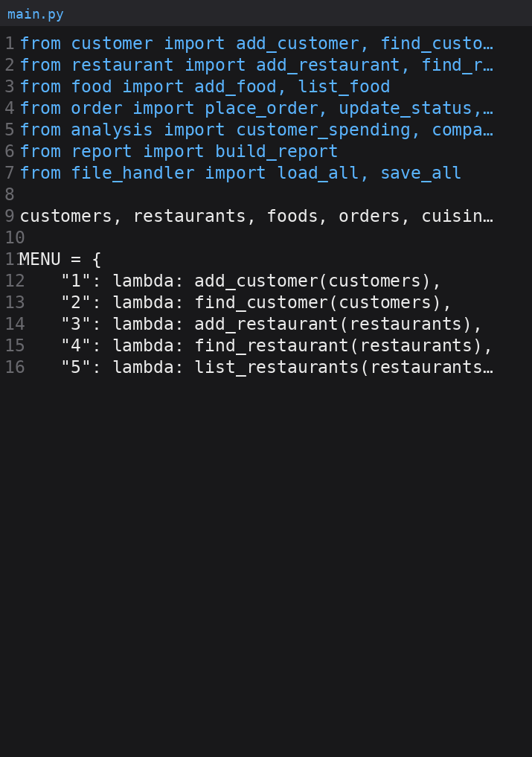
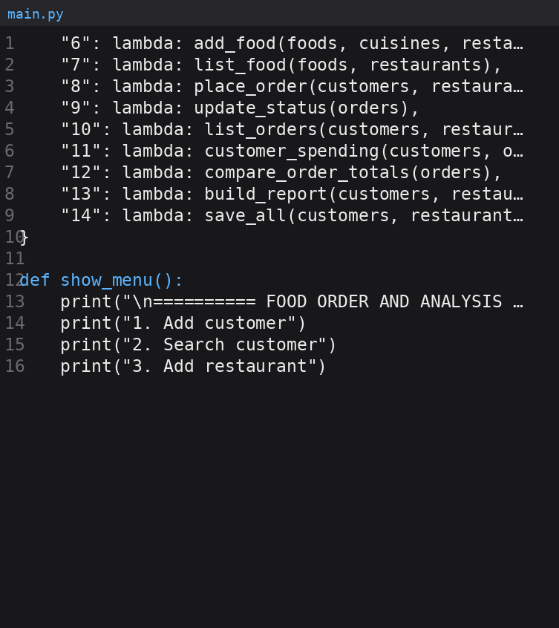
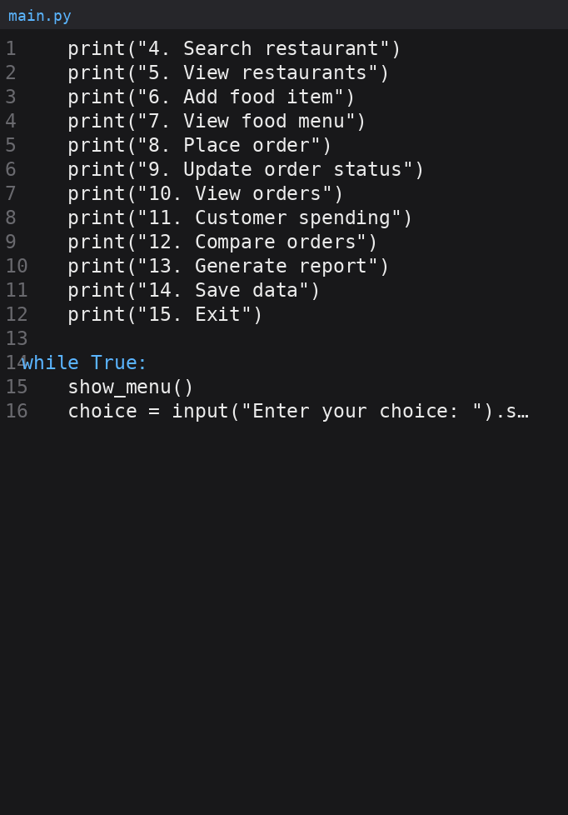
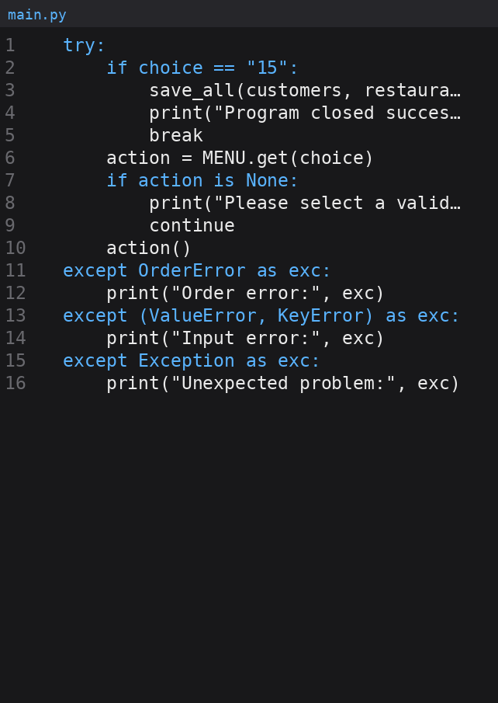
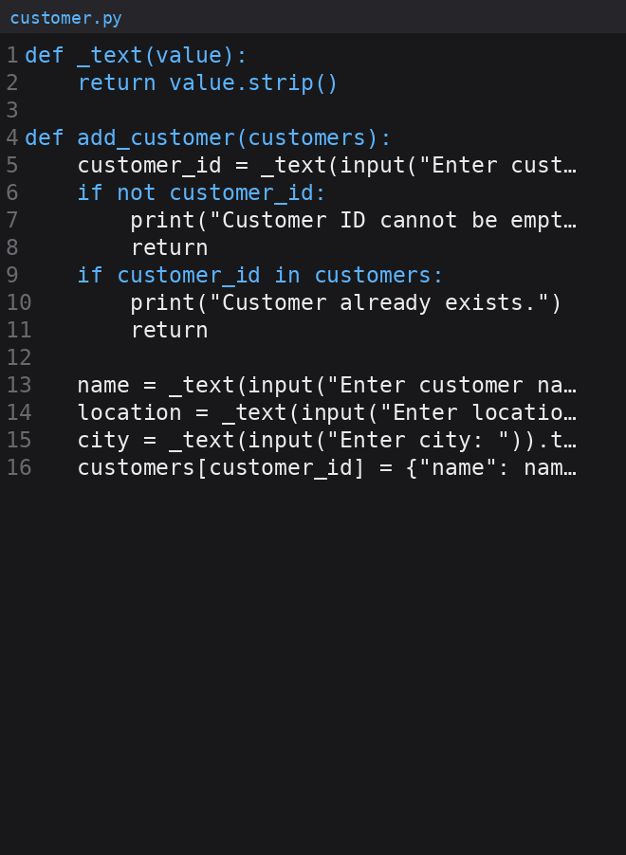
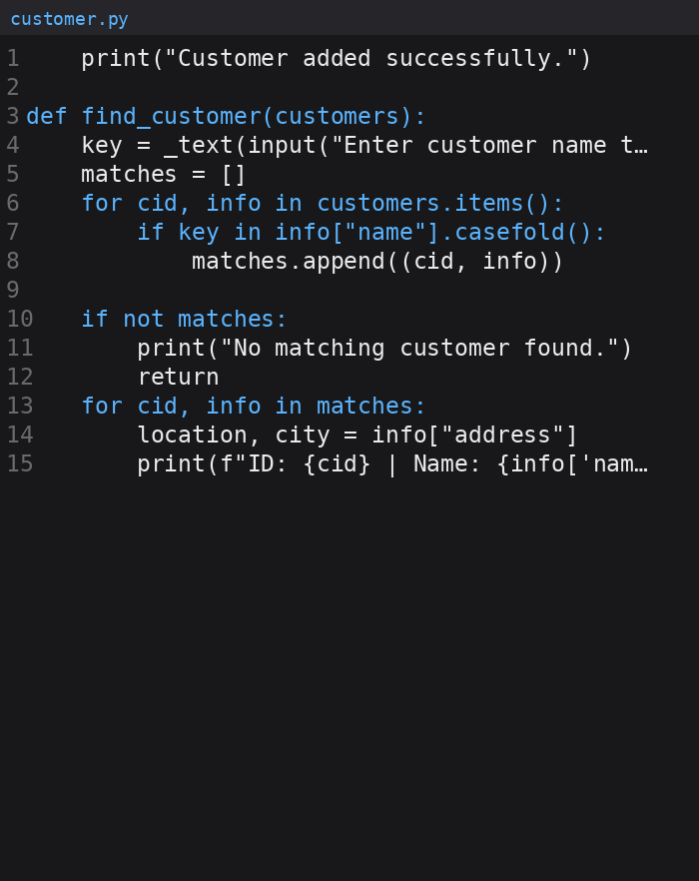
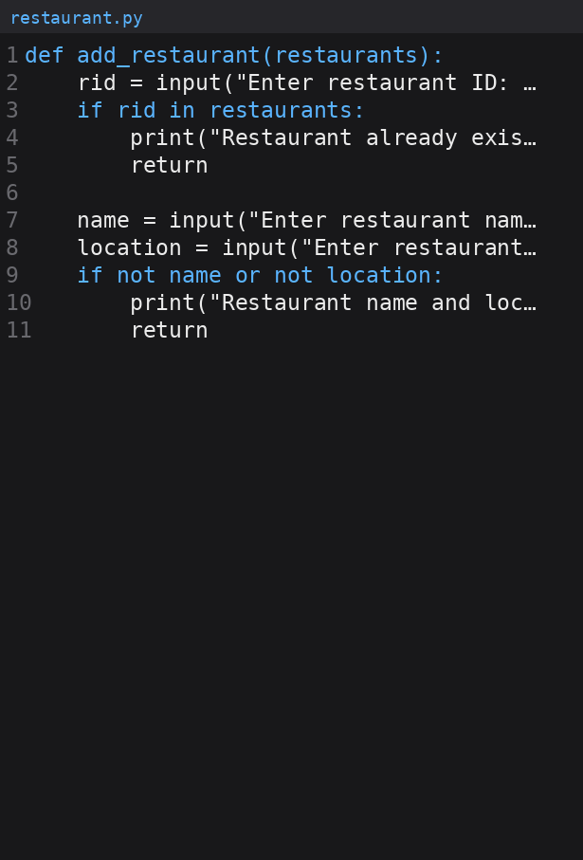

customer.py:-

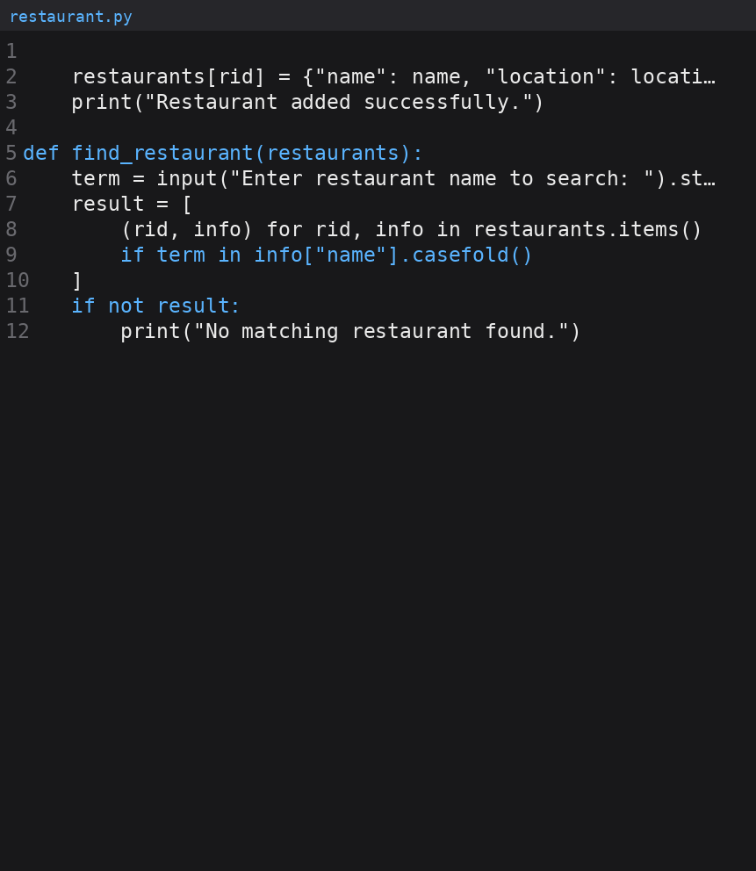

restaurant.py

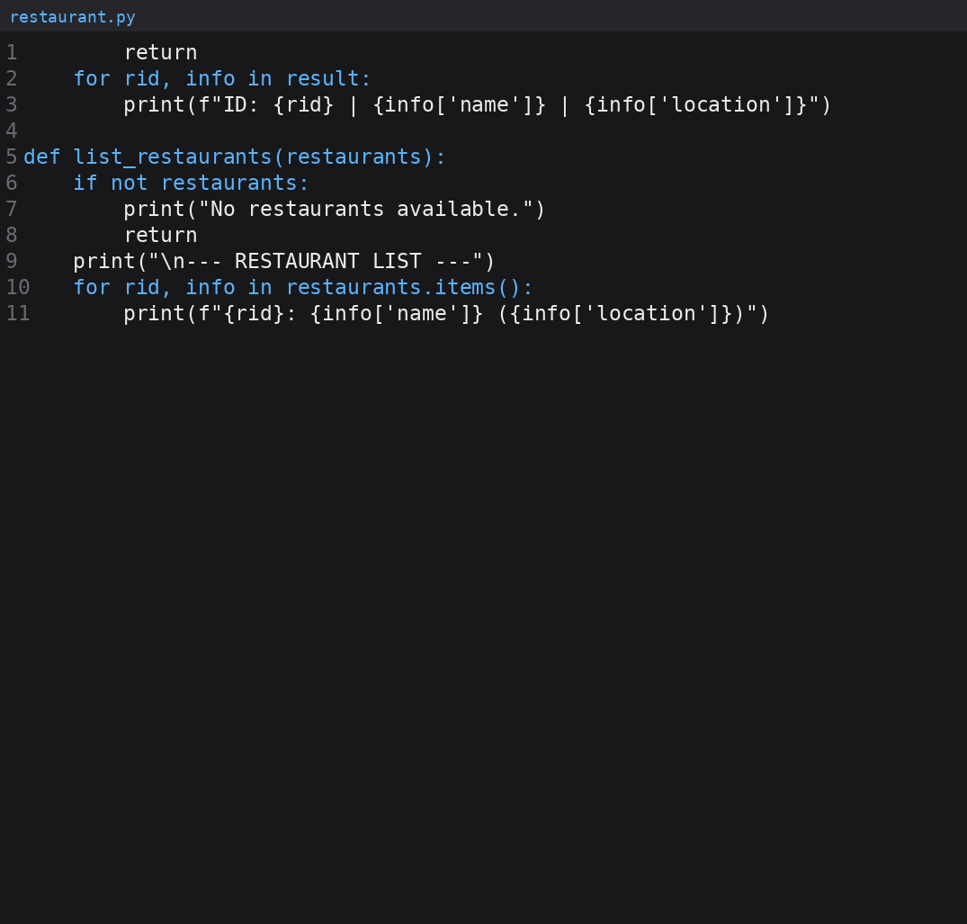
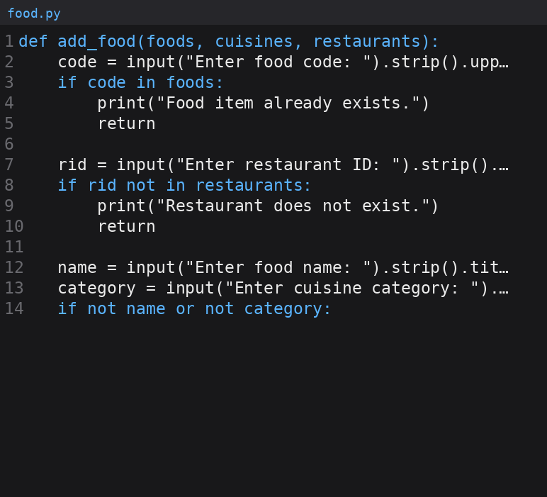
food.py

food.py:-

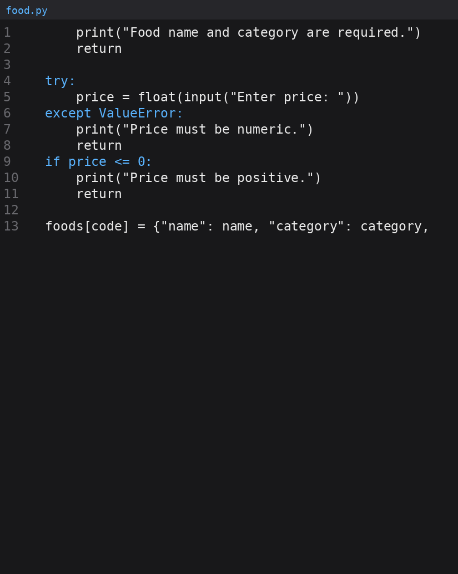
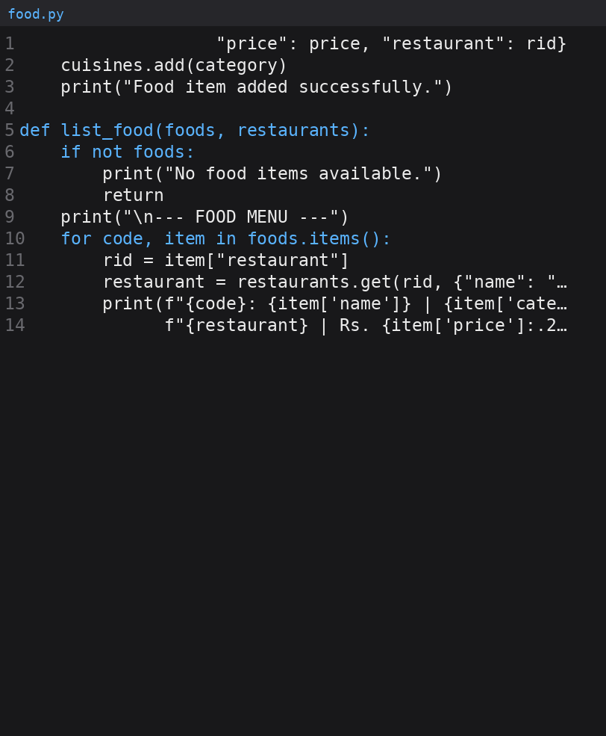

order.py

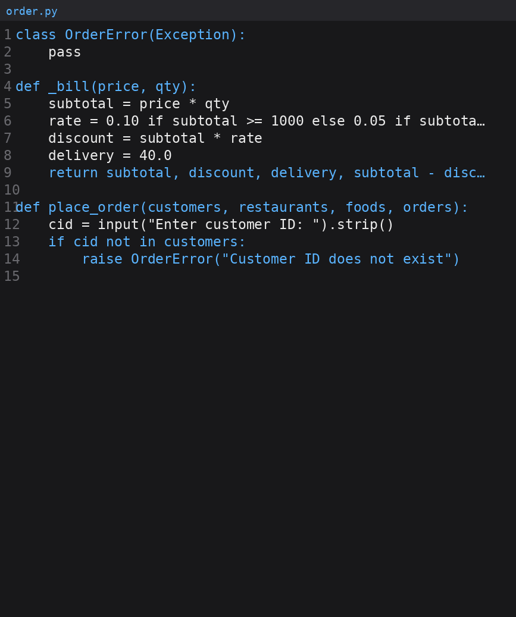
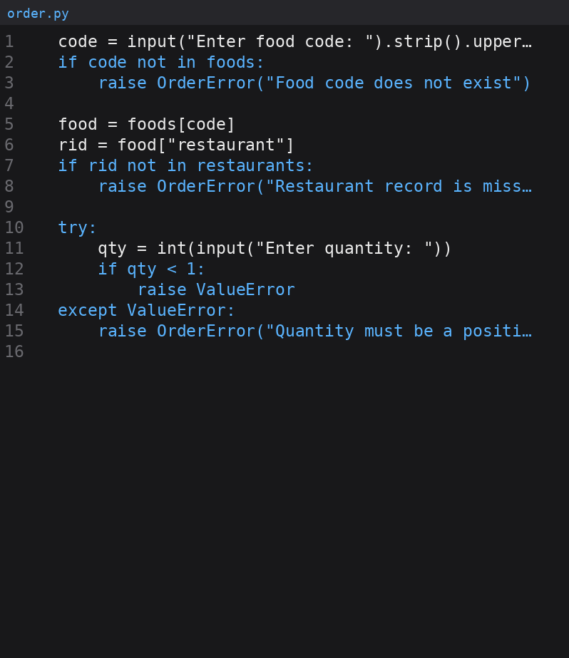
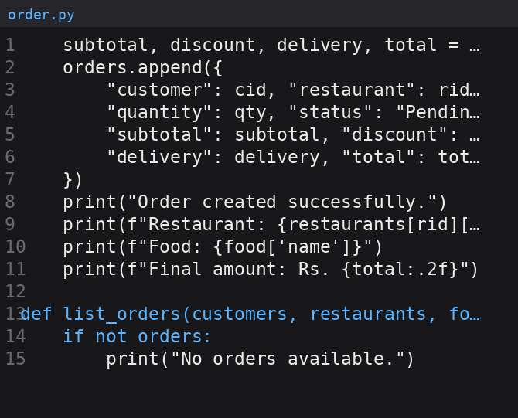
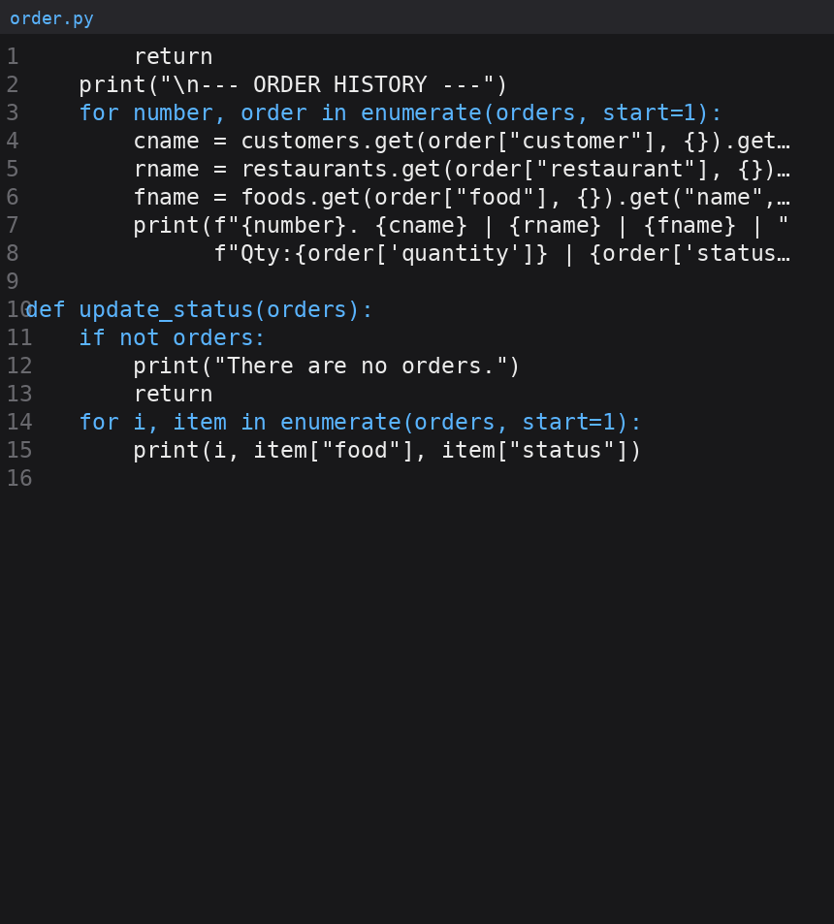
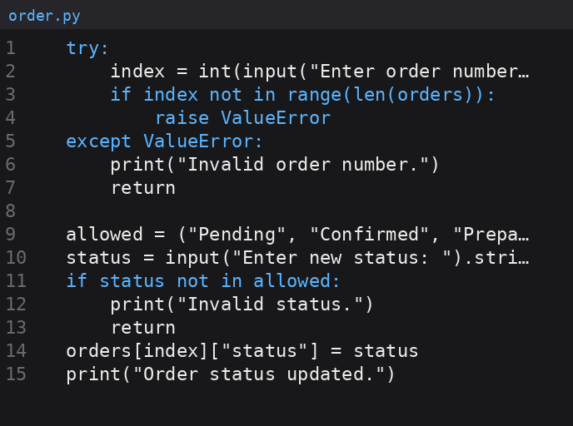

analysis.py

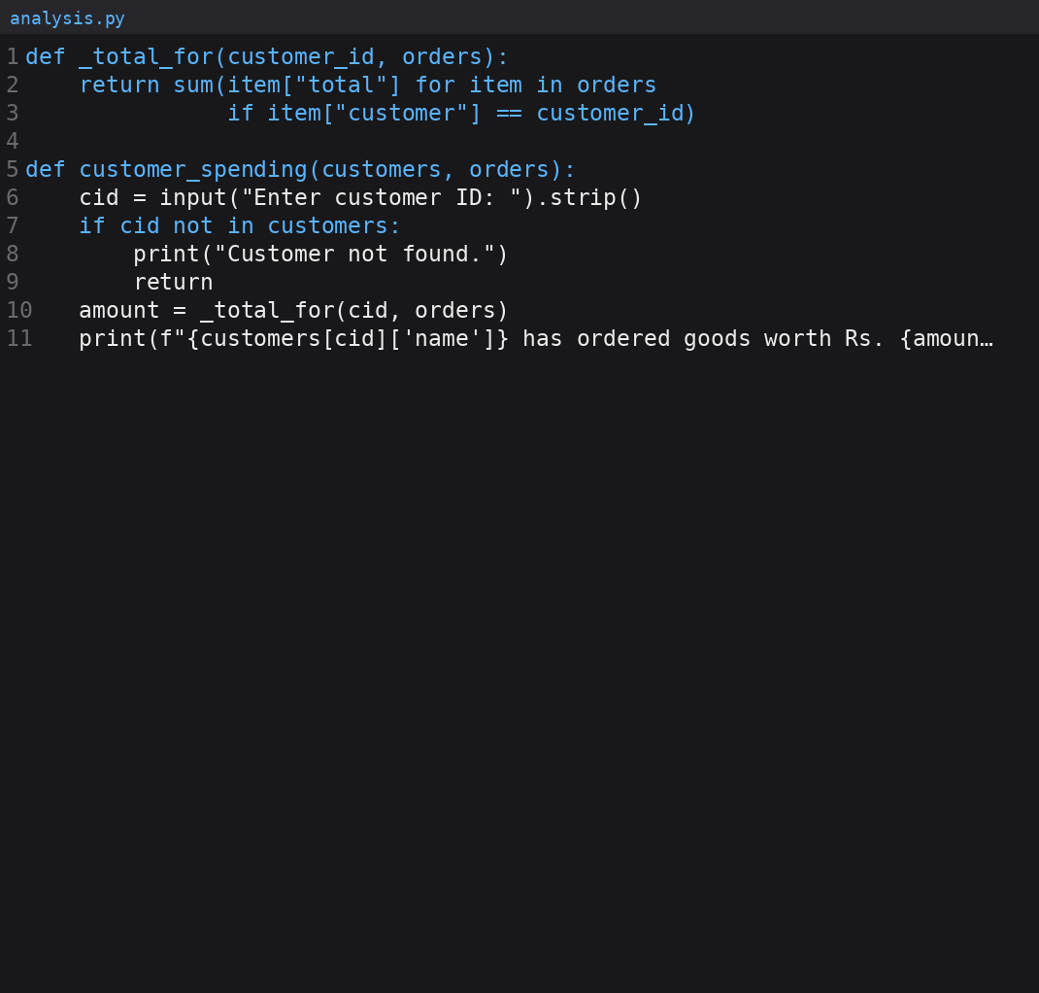
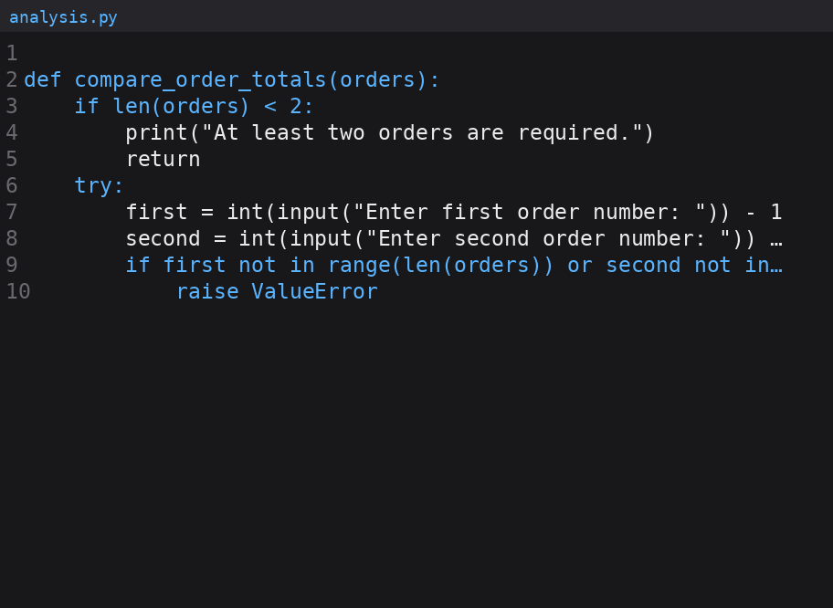
report.py

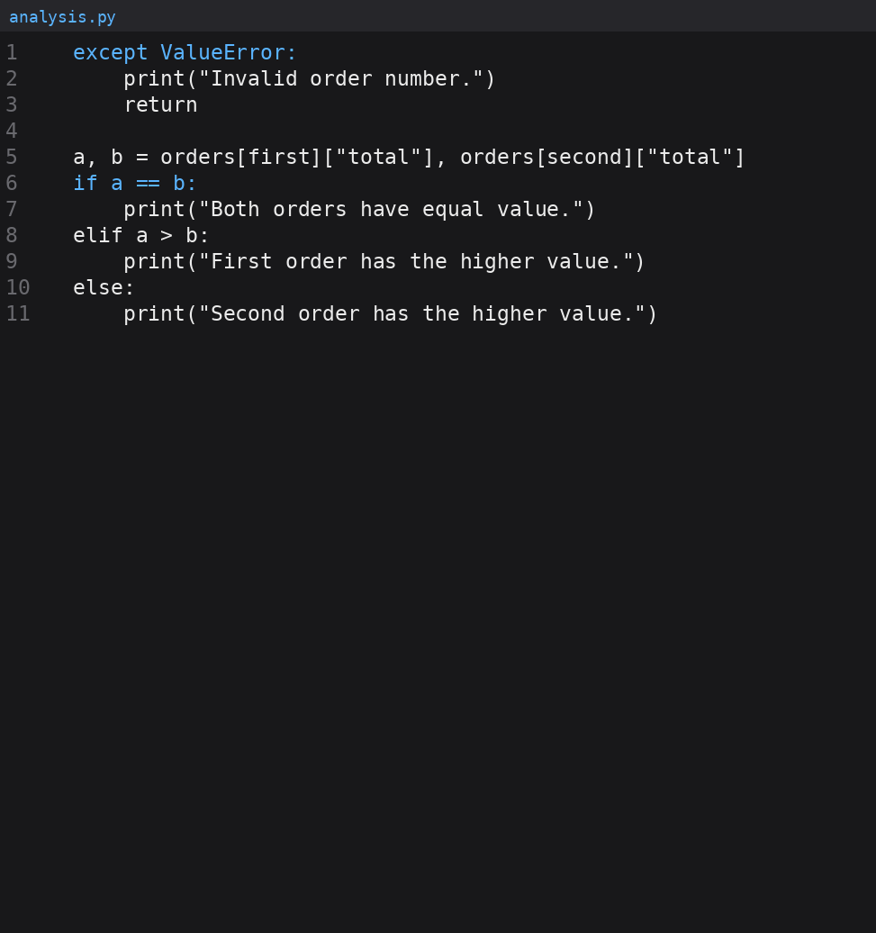
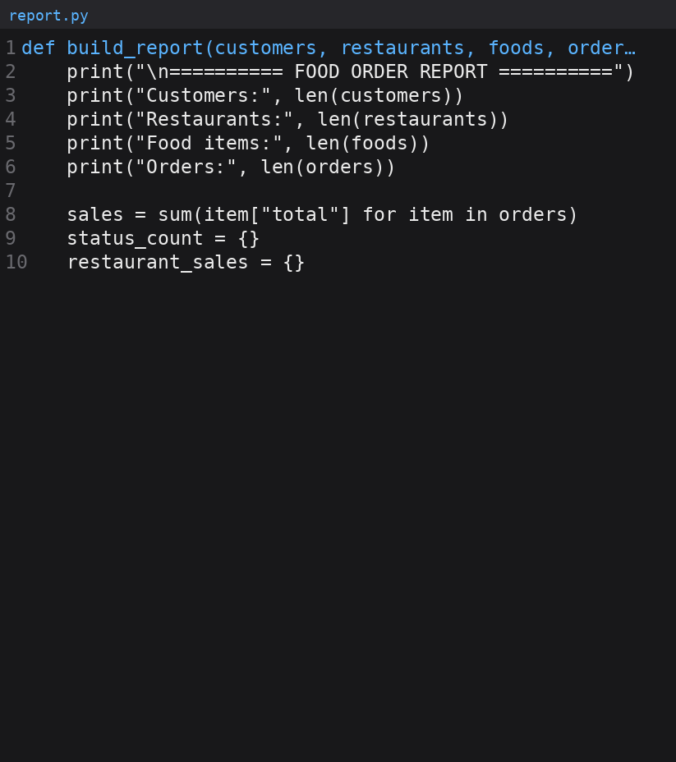
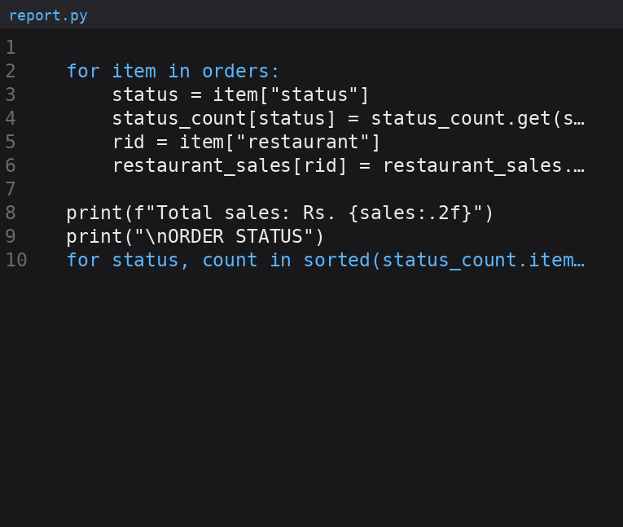

file_handler.py

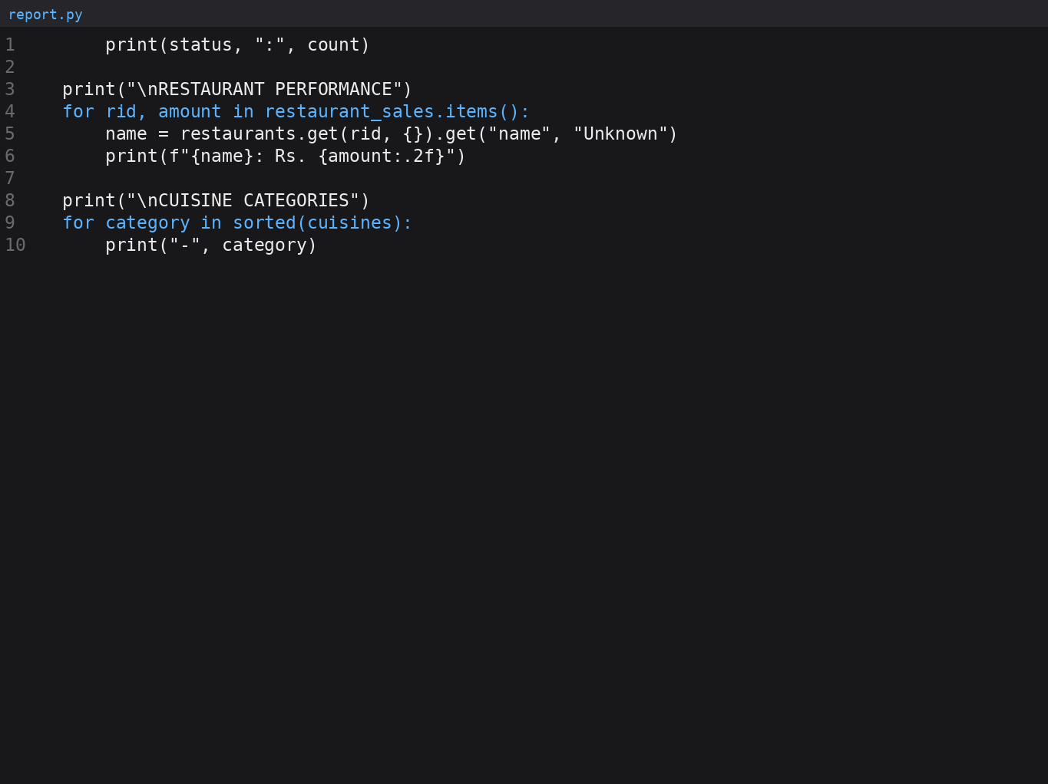
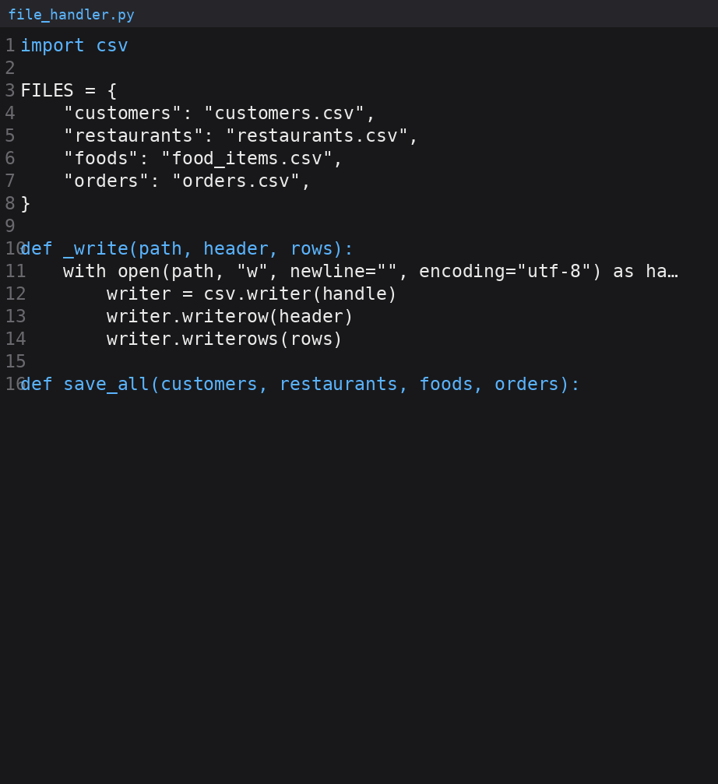
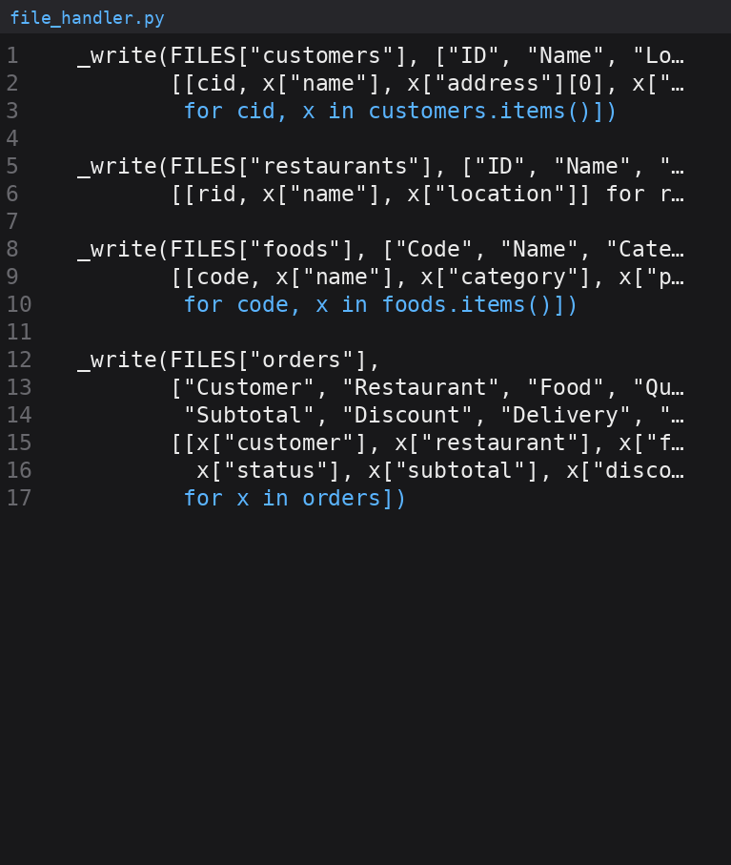
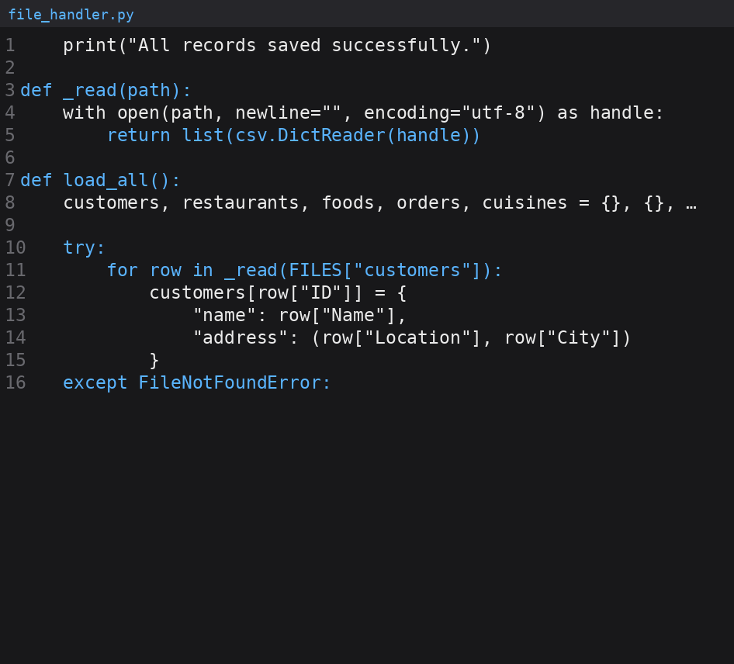
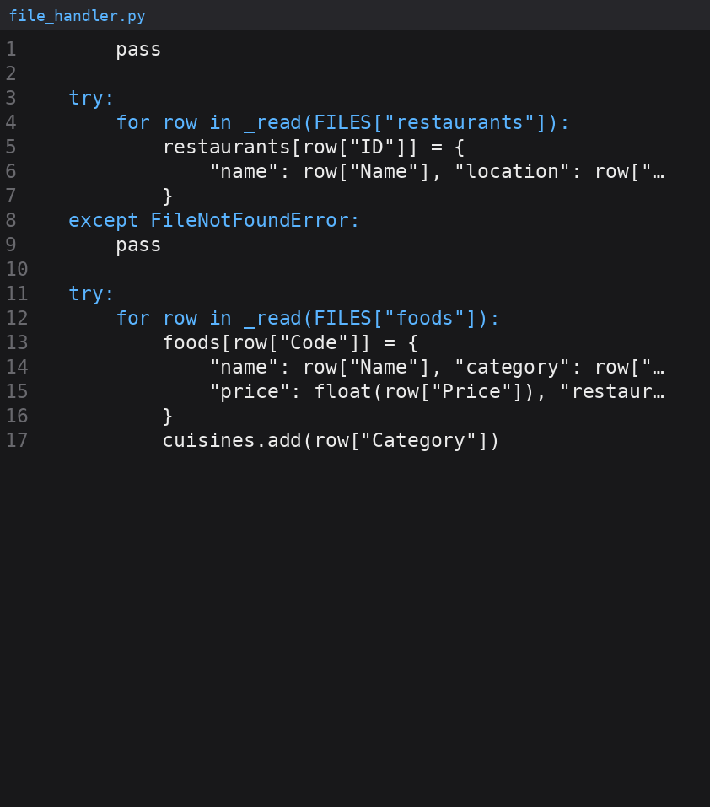
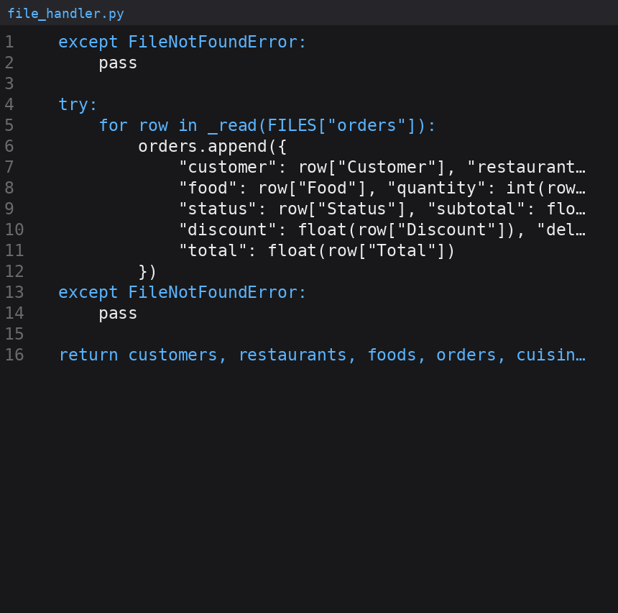

5.2 Flowchart
I notice the flowchart shows the flowchart. The flowchart first loads the saved data. Then shows the menu. The user selects an option the flowchart carries out the related task and the flowchart returns to the menu. The flowchart keeps repeating until the user chooses Exit.
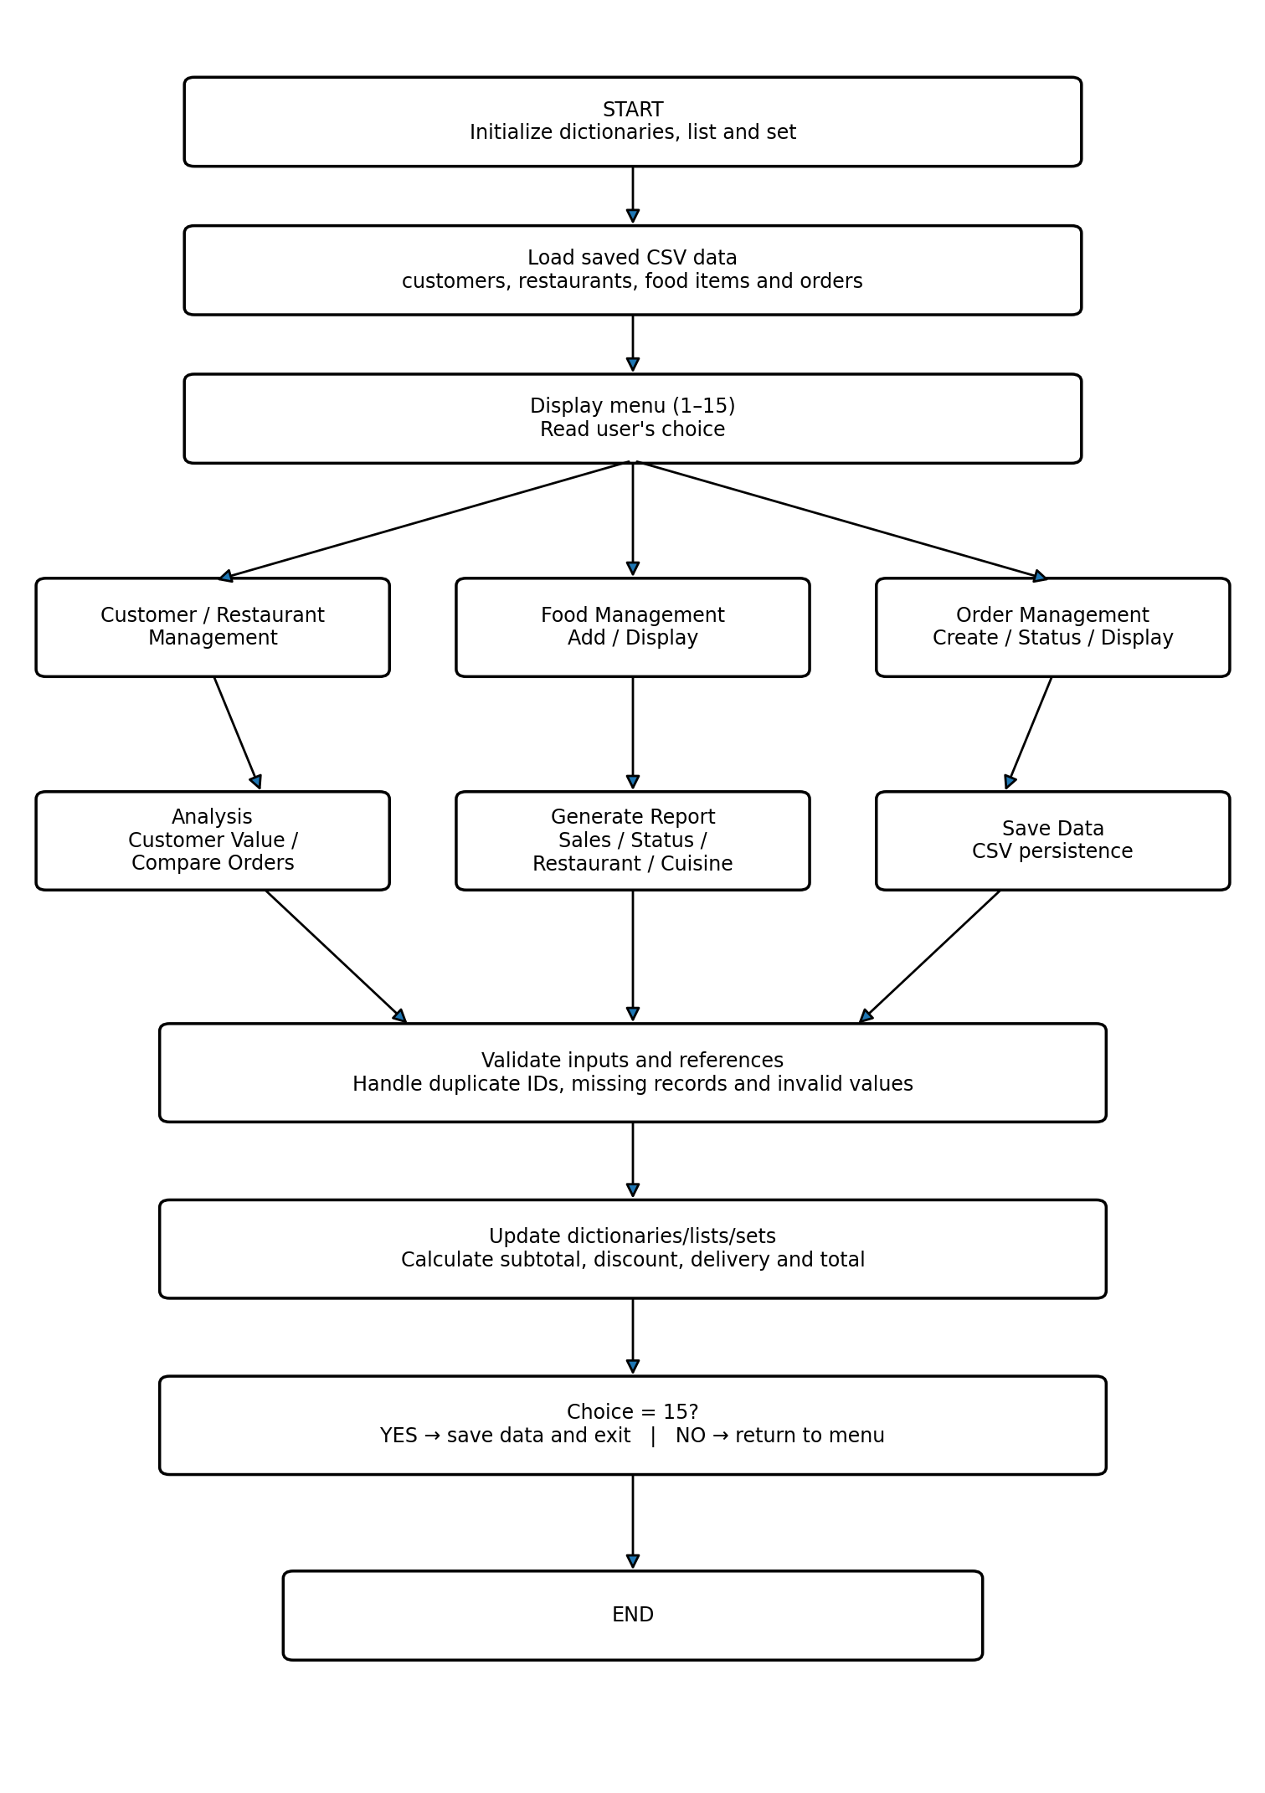
Figure 1. Implementation Flowchart of the Food Order and Analysis Management System

The following test cases are based on the outputs shown in the screenshots. The expected result is what the program should do for the given input, while the actual result is what was seen during execution.
7. Test Cases and Expected / Actual Results
No. | Test | Input / Condition | Expected Result | Actual Result
1 | Add customer | New customer details | Customer should be added | Customer added successfully
2 | Search customer | Customer name | Matching customer should appear | Customer details displayed
3 | Add restaurant | New restaurant details | Restaurant should be added | Restaurant added successfully
4 | Add food item | Food code, category and price | Food item should be added | Food item added successfully
5 | Create order | Customer, food and quantity | Order total should be calculated | Order created and final amount shown
6 | Change status | Order changed to Delivered | Order status should change | Status changed successfully
7 | Customer order value | Existing customer ID | Total order value should be shown | Customer value displayed
8 | Compare orders | Two order numbers | Higher total should be identified | Orders compared successfully
9 | Generate report | Report option | Order and restaurant details should be shown | Food order report generated
10 | Save data | Save option | Records should be stored | All data saved successfully
8. Execution Screenshots / Output
The screenshots in this section show the program running through its main options. They include customer and restaurant records, food items, order creation, order status changes, order analysis, report generation and data saving.

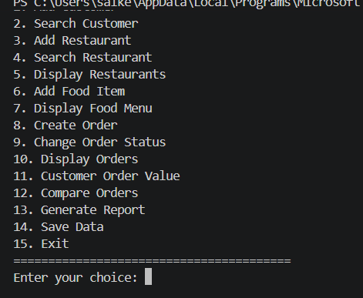

Figure 2. Main menu of the Food Order and Analysis Management System

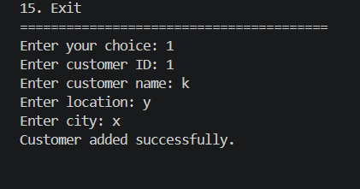
Figure 3. Adding a customer successfully

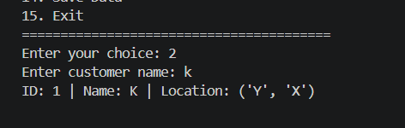
Figure 4. Searching for a customer

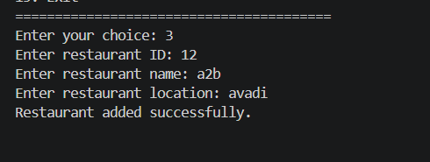
Figure 5. Adding a restaurant successfully
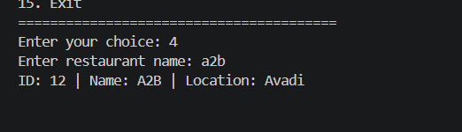
Figure 6. Searching for a restaurant

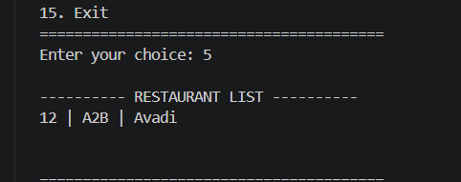
Figure 7. Displaying the restaurant list

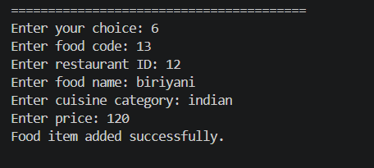
Figure 8. Adding a food item successfully

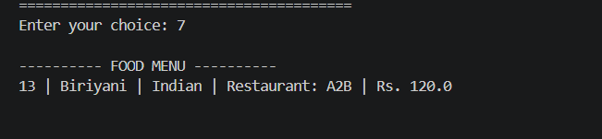
Figure 9. Displaying the food menu

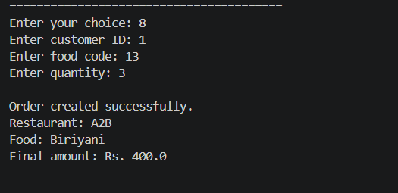
Figure 10. Creating an order and calculating the final amount

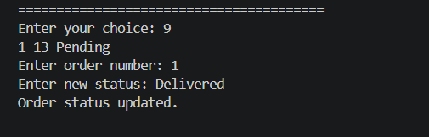
Figure 11. Changing the order status to Delivered

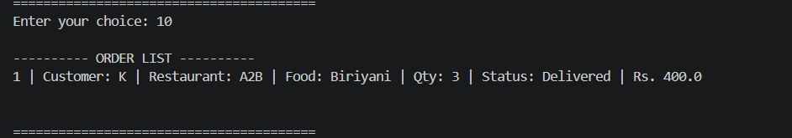
Figure 12. Displaying the order list
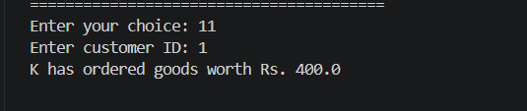
Figure 13. Calculating the customer's total order value
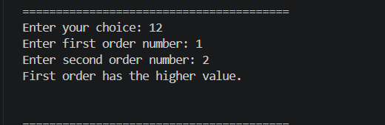
Figure 14. Comparing two orders

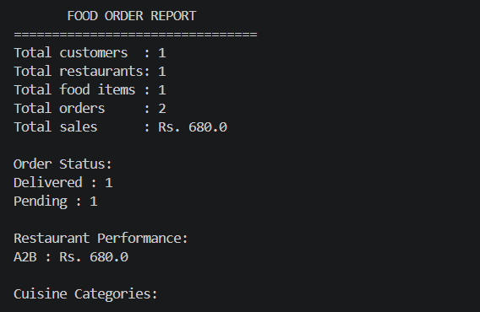
Figure 15. Generated food order report

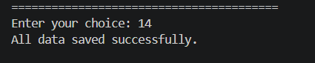
Figure 16. Saving all data successfully
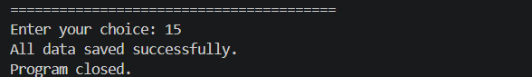
Figure 17. Saving data and closing the program

Validation summary:
The output evidence demonstrates that the program can create and retrieve customers, create and retrieve restaurants, add and display food items, create and update orders, display order records, calculate customer order value, compare orders, generate an overall report and save data. The final report output shows 1 customer, 1 restaurant, 1 food item and 2 orders with total sales of Rs. 680.0; the displayed order status counts include Delivered = 1 and Pending = 1. The supplied output also confirms successful data saving and program closure.
9. Analysis and Discussion
The program was tested using the different menu options shown in the output screenshots. The basic functions worked together as planned. Customer and restaurant details could be added and searched. Food items could be linked to a restaurant and displayed in the food menu. Orders could be created with quantity, discount and delivery charge included in the final amount. The status of an order could also be changed.
The analysis options gave the total value of a customer's orders and allowed two orders to be compared. The report option showed the number of records, total sales, order status and restaurant sales. The CSV files allowed the records to be saved so that they could be used again later.
The project covers the main points in the assignment rubric. Python variables, expressions, functions, modules and control statements are used throughout the program. String operations such as strip(), lower(), upper() and title() are used while entering and searching data. Lists, dictionaries, tuples and sets are used for different types of information. Exception handling is used for incorrect order quantity and other input errors. The project also includes two useful custom operations: finding a customer's total order value and comparing two orders.
One limitation is that this is a console-based prototype. It does not include a graphical interface, online payment or a real delivery service. The CSV files are also suitable mainly for a small project. Even with these limits, the program demonstrates the Python concepts required in the assignment.
10. Conclusion
The Food Order and Analysis Management System was completed as a menu-driven Python program. It can manage customers, restaurants, food items and orders. It also calculates order amounts, changes order status, compares orders, prepares a report and saves the records. The testing screenshots show that the main functions worked during execution. The project helped in applying Python data structures, functions, modules, string handling, exception handling and file handling in one application.
11. Individual Contribution of Group Members
The submitted work represents the project completed for this assignment. The contribution below records the work covered by the supplied source code, pseudocode, testing and output.
Student | Contribution
YUDHISHT RAM D.A | Completed the Python program, module design, pseudocode, testing, output screenshots, analysis and report preparation.
12. References
1. CSA0801 – Python Programming Assignment Question and Assessment Rubrics, Department of Computer Science and Engineering.
2. Python standard library documentation for basic Python and CSV file handling concepts.
3. Project source code and execution outputs prepared for the Food Order and Analysis Management System.

